Minimax Algorithm
AIM:
To write a Python program to implement the Minimax algorithm for decision-making in games.

ALGORITHMS:
- Start.
- Construct the game tree representing possible moves.
- Assign utility values to the terminal states.
- Identify the maximizing player (MAX) and minimizing player (MIN).
- If the current node is a terminal node, return its utility value.
- If it is a MAX node, select the maximum value among its child nodes.
- If it is a MIN node, select the minimum value among its child nodes.
- Propagate the calculated values upward through the game tree.
- Select the move with the best value for the maximizing player.
- Stop.
CODE:
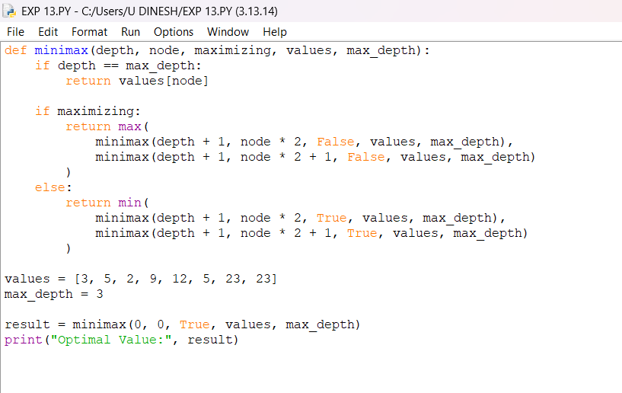
OUTPUT:
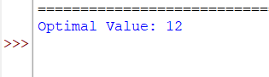
RESULT:
Minimax Algorithm: The optimal move is selected by considering the possible moves of both players.

